CHAPTER 2
- Motherboards sometimes are called as the main board, system board or the planar board. What is the main function of a motherboard?
- Motherboard can be categorized in 2(TWO) categories, Integrated(Embedded) and Non-Integrated motherboards. Differentiate both of it.
- There are some disadvantages of Integrated(Embedded) motherboard. In order to upgrade this kind of motherboard, bypass is needed to disable the embedded device on the motherboard. List any 2(TWO) suggestion that you could do in order to bypass that embedded device.
- Label the following components on the given motherboard.
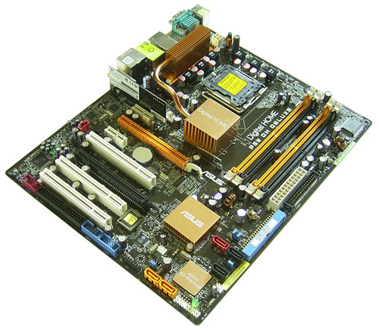
- CPU/processor
- Power Plug-in
- Memory Slot
- IDE controller
- PCI-e
- CMOS Battery

- Expand the following terms:-
- CNR -
- PCI -
- AGP -
- ISA -
- Why chipset has become one of a very important criterion in choosing a motherboard?

CHAPTER 3
- The only purpose of motherboard socket is to provide a place to insert the processor into the motherboards. Socket exist in 2(TWO) forms. List both of it.
- Give 1(ONE) disadvantage of LIF socket over ZIF socket.
- A computer system will produce large amounts of heat during operation. State any 2(TWO) causes that might increase the level of heat in computer system.
- Give 1(ONE) advantage and 1(ONE) disadvantage of water cooling system.
- Differentiate single-core processor and multi-core processor.
- Give 3(THREE) examples of multi-core processor.
- Define clock multiplier.
- Find the clock multiplier for the following problems:-
- Pentium 4, 2.0GHz with a motherboard FSB 250MHz.
- Athlon XP 2400+ and a motherboard FSB 366MHz.
- Pentium 4, 2.4GHz with a motherboard FSB 600MHz.

